

COMPUTER ARCHITECTURE

CLOUD COMPUTING

THE MICROSOFT CLOUD

Author: B00060572

Lecturer: Conn Cremin

B00060572 | Computer Architecture Microsoft Cloud Computing

CONTENTS

1. Introduction
2. Virtualization
3. Cloud Computing – Service Model
4. Cloud Computing – Hosting Model
5. Microsoft Cloud – Data Storage
6. Microsoft Cloud – Windows Azure
7. Future of Cloud Computing

9. Conclusion

10. References

B00060572 | Computer Architecture Microsoft Cloud Computing

Introduction

In the more recent history of Information Technology a new field of services has emerged. Cloud computing is an all encompassing practical business solution to 90% of business enterprises worldwide, Companies that rely on the latest data, data storage and up to the minute online services.

Third party cloud vendors can supply computer power & data storage far more cost effectively than nearly all internal IT departments. By switching to cloud computing companies can make large savings in lots of areas and still remain competitive.

The best comparable development in the business world can be drawn from the early 20th Century. In the early 1900’s businesses had on site generators to power their factories and offices. By the mid 1930’s the turn over was complete and nearly all business relied on the national grid for their electricity. Initially many companies had been worried about switching to an external supplier however it soon became obvious that in house generation was no longer a practical and cost efficient means of getting electricity. Similarly the development of data as a commodity has brought a wave of techniques and skills to manage data globally. Skills like, data storage, software as a service, platform as a service and infrastructure as a service.

Cloud computing has been made possible by advances in many fields of technology. In most part it has been down to the emergence of a strong reliable Internet network world wide but also the operating systems and virtualization software that manage data flow and storage in data centers globally.

B00060572 | Computer Architecture Microsoft Cloud Computing

Virtualization

Virtualization and cloud computing are two terms synonymous with each other. Sometimes these words are used interchangeably as if they both mean the same thing. The fact is that they do not. Although they do work hand in hand, virtualization is a component of cloud computing.

Virtualization is the separation of a computers operating system from the under lying hardware. Before virtualization when an OS was installed on to a physical piece of hardware like a hard drive, it became interconnected to that specific piece of hardware. If you wished to move the OS from this machine it became a tedious and time consuming affair as the OS and Hard Drive were “coupled”.

In order for virtualization to take place, a very important piece of software is needed to separate the hardware from the operating systems sitting on top of it. This is where Hypervisors are introduced. Hypervisors are a virtual layer inside a computer that sits above the hardware and beneath the operating systems running on the computer. Hypervisors are a tremendously important part of virtualization and they allow an instance on an OS to be installed on the computer without adversely affecting the hardware or becoming interconnected to the specific Hard Drive it is running on. The most important thing to understand here is that the OS becomes “coupled” with the hypervisor rather than the hardware.

If you now wish to move an instance of your OS to a new drive on different hardware, all you need to do is have the same hypervisor installed on the new piece of hardware you wish to migrate to and it becomes as easy as moving a file between to drives. You no longer have to install migration software that is tedious and time consuming.

Instead of one organization having numerous servers to run numerous tasks. They can now consolidate their information on to one server that can dynamically grow and shrink depending on data needed at any given time. The organization can cut costs by having just one high end spec computer that can handle large work loads efficiently rather than having numerous computers that may not be spreading the work load evenly due to the rigidness of the old system.

This is such a massive part of cloud computing because it no longer ties down a piece of hardware to one OS. The hardware is now a flexible and elastic server, which can run multiple operating systems when needs be or can run none if the work load is not needed. This is made possible by a management OS that runs on the hypervisor and can delegate out running configurations for the computer at any given time. The automated management OS can even switch off the unit if there is no data storage or work required of it.

There are two types of hypervisor.

TYPE 1: A hypervisor can be installed directly on to a computer with no OS beneath it and then installing the instances of OS required on top of that.

* HARDWARE / HYPERVISOR / INSTANCE OF OS

TYPE 2: An OS can be already installed on the computer before installing the hypervisor. Then from there, further instances of OS can be installed on top of the hypervisor.

* HARDWARE / OS / HYPERVISOR / INSTANCE OF OS

B00060572 | Computer Architecture Microsoft Cloud Computing

Cloud Computing

Service Models

Where virtualization is the separation of OS from the hardware beneath it. Cloud computing goes one step further and is the separation of applications from the operating system sitting on top of the instance of OS on top of the hypervisor.

* HARDWARE/OS/HYPERVISOR/INSTANCE OF OS/CLOUD/APPLICATION

This set up allows the application to be truly as flexible and manageable as possible. Making sure applications never have down time, applications can be switched between servers in milliseconds. This makes sure that servers are truly being used to their full working efficiency.

Cloud computing offers three fundamental service models that make up the cloud service as a whole.

* SaaS (Software as a Service)

This service allows users to use of the shelf applications, which are accessed over the Internet. Applications such as Microsoft Office web apps, Google Docs & ZOHO. The user does not manage or control the underlying cloud infrastructure (network, servers, operating systems, storage).

* PaaS (Platform as a Service)

This service provides users with a developer’s environment and tool set for creating new online applications. Microsoft Azure is a Platform Service that allows users to develop and run windows applications online. The user does not manage or control the underlying cloud infrastructure (network, servers, operating systems, storage), but has control over the deployed applications and possibly configuration settings for the application-hosting environment.

* IaaS (Infrastructure as a Service)

This service caters for businesses with already existing applications or specific applications to be created and supported by the cloud-hosting server. Migration of existing applications from a company data center to a cloud-host is a common and effective way of reducing IT costs. The user does not manage or control the underlying cloud infrastructure but has control over operating systems, storage, and deployed applications.

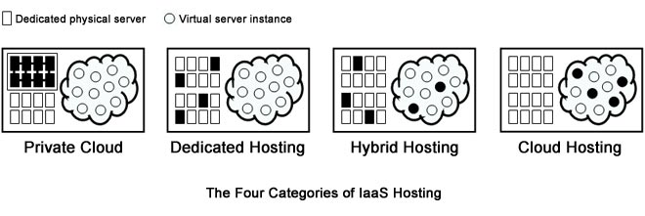

These three services allow users to store data and run applications online, each service offering a different level of user control. The four hosting deployment models will be explained in more detail on the next page.

B00060572 | Computer Architecture Microsoft Cloud Computing

Cloud Computing

Hosting Models

On top of the three service models provided by a cloud vendor, there are four hosting deployment models. The vendor offers these four models as methods of storing the users data depending on the users requirements.

* Private cloud

The private cloud is developed for use by one single organization. It may be owned, operated and managed by the organization, a third party or the cloud vendor. It may exist on or off premises.

* Community cloud

This model is provisioned for an exclusive community of users with a common involvement. For example all Government organizations within Ireland may share computing infrastructure on the cloud to manage data related to all Irish citizens. It may be owned, managed, and operated by one or more of the organizations in the community, a third party, or some combination of them, and it may exist on or off premises of the vendor.

* Public cloud

The public cloud is open to use by the general public. The cloud may be owned by an organization however they have no visibility or control where it is hosted and it exists on the premises of the cloud vendor.

* Hybrid cloud

The hybrid cloud is a composition of two or more cloud hosting deployment models (e.g., public cloud & private cloud) these individual clouds remain unique however are bound together allowing load balancing between the respective clouds.

Depending on the users cloud computing requirements, a combination of one of the four hosting options and either the PaaS or IaaS service model can be selected to suit the users needs and supply them with closest service requirements needed.

B00060572 | Computer Architecture Microsoft Cloud Computing

Microsoft Cloud

Data Storage

The Microsoft cloud exists in their vast worldwide network of data centers that provide the foundation for a wide array of online services. The Microsoft data center infrastructure that is in place globally supports over 200 online services (e.g., Bing, MSN, Hotmail, Sky Drive). More than 1 billion customers in 20 million businesses in over 70 countries use these services each year.

Data Storage is an area in which Microsoft have been operating in since 1989. Strategic investments have been made and continue to be made by Microsoft in this field since entering the area of data storage. From 1989 - 2004 Microsoft built data centers to address early computer systems that required controlled temperature environments in which to operate. From 2004 - 2007 Microsoft integrated their second-generation data center blueprint to cater for the emerging cloud computing market.

In 2008 Microsoft announced the construction of a third-generation data center in Dublin, Ireland. A data center that would incorporate features of their second-generation blueprint that allowed data storage to be so successful. Features that include

* Controlled temperature environments to house tens of thousands of high performance processing and storage servers in high-density racks that are separated by hot and cool air isles.
* Chillers and air handling equipment to ensure precise control of environmental conditions within the server room.
* Uninterruptable Power Supplies (UPS system) and vast banks of batteries ensure electricity remains continuous in the event of a short-term power disruption.
* Emergency generators to provide back up power for extended outages and for planned maintenance. These generators can operate the data center with on site fuel reserves in the event of a natural disaster.
* High-speed fiber optic cable network connecting the data center with other important data hubs and increase over all service resiliencies.

In 2009 Microsoft opened the doors of its 38,000m² data center in Dublin. By making adjustment to the proven successful features of their pervious generation data centers, Microsoft could hone their efficiency and improve their carbon emissions. The Dublin data center uses less than 1% water consumption than that of a traditional data center and improves energy efficiency up to 50% when compared to their first-generation centers of similar size.

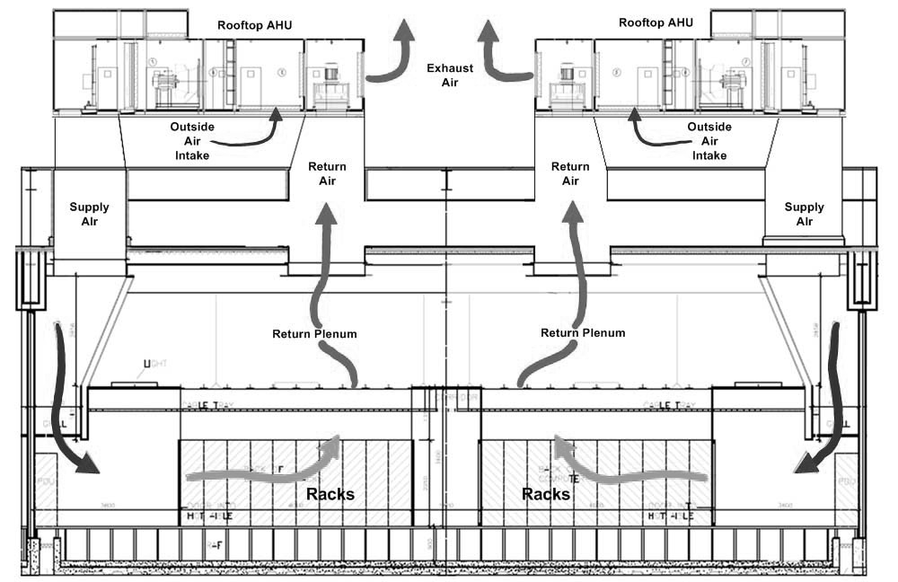

B00060572 | Computer Architecture Microsoft Cloud Computing

Microsoft Cloud

Windows Azure

Windows Azure is a PaaS & IaaS model that provides a computing platform as a service in the Microsoft cloud. Organizations can subscribe to Azure and easily deploy applications in the cloud based infrastructure without encoring huge costs involved in planning, purchasing, configuring and maintaining the hardware and software required to deploy the applications.

The Windows Azure platform consists of three main components.

* Virtual Machines

Part of IaaS model is the ability to create and implement a virtual machine on demand. The virtual machine can be a standard image from the Microsoft gallery or it can be one supplied by the user. Virtual Machines in the IaaS model are paid for by the hour and can be turned on or off instantaneous depending on the users requirements.

* Web Sites

Azure provides a management web environment called Web Sites, to run websites or run applications online. This way depending on traffic on a website, virtual instances of a website can grow dynamically in an act called Load balancing. Windows Azure Web Sites offers both a shared option, where an instance of a website runs on a virtual machine shared with other websites or on an individual reserved virtual machine, depending on the users needs.

* Cloud Services

Azure Cloud Services allows a user to create and application on any software of choice and have an instance of it hosted on the Microsoft cloud. The application can use software such as C, C#, Java, PHP, Python or any other programming language and have the application hosted and executed as an instance on a virtual machine.

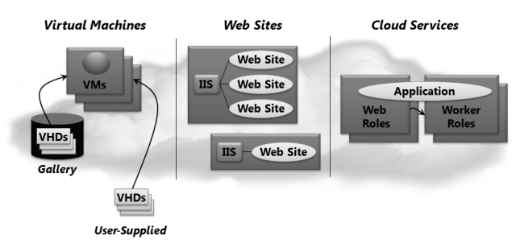

B00060572 | Computer Architecture Microsoft Cloud Computing

Future Of Cloud Computing

“Cloud computing is the next step forward in the world of IT. Cloud computing will not only be driven by a desire and necessity to do existing things better but by a demand do to entirely new things.” – Christopher Barnatt

The most important aspect of cloud computing is truly the collaboration and data sharing aspect. In order for technology to continue pushing forward as fluidly and progressively as possible these characteristics must be adapted by the industry. Local software and data inevitably constrain collaboration and with cloud computing data can be set free and utilized in ways previously unknown.

The only real argument against cloud computing going forward is security. Data protection must be guaranteed if cloud computing is to remain a steady force. All cloud vendors have a model that provides the user a secure connectivity and messaging service between the applications running on the host cloud. This model must remain intact in the future if not enhanced to be made even greater.

Ireland can only benefit from participating in the current and future developments of cloud computing and having companies like Microsoft and Google investing money, jobs and resources in Ireland. In time it can be looked back upon that Ireland’s involvement in cloud computing was a wise choice.

Conclusion

Cloud computing is the next logical step for businesses and IT departments globally. It is no longer cost effective to have in house data centers for over 90% of company’s worldwide. Like the analogy I drew on in the introduction. Data storage is now a commodity like energy. Outsourcing your data storage to the cloud allows data to be utilized in a far more cost efficient and resourceful manner.

Cloud computing significantly reduces the cost and difficulty of administrating of computers and the network they operate on. Cloud vendors allow organizations to save money on information technology infrastructure, as well as hardware or software licenses. Cloud services can often be customized and flexible to use, and providers can offer advanced services that an individual company might not have the money or expertise to develop.

Cloud computing is now a very big part of IT and in fact cloud computing touches on just about every aspect of personal and business computing as we know it.

Cloud computing is service with a solution.

B00060572 | Computer Architecture Microsoft Cloud Computing

References

* www.explainingcomputers.com (2012) *Cloud Computing*. [online] Available at: http://www.explainingcomputers.com/cloud.html [Accessed: 1 May 2013].
* www.networkworld.com (2012) *Are community cloud services the next hot thing?*. [online] Available at: http://www.networkworld.com/news/2012/030112-are-community-cloud-services-the-256869.html [Accessed: 1 May 2013].
* www.nist.gov (2012) *The NIST Definition of Cloud Computing*. [online] Available at: http://csrc.nist.gov/publications/nistpubs/800-145/SP800-145.pdf [Accessed: 1 May 2013].
* www.priv.gc.ca (n.d.) *Introduction to Cloud Computing*. [online] Available at: http://www.priv.gc.ca/resource/fs-fi/02_05_d_51_cc_e.pdf [Accessed: 1 May 2013].
* www.thecloudtutorial.com (2010) *Types of cloud computing*. [online] Available at: http://thecloudtutorial.com/cloudtypes.html [Accessed: 1 May 2013].
* www.youtube.com/user/MSGFSTeam?feature= (2012) *Microsoft GFS Datacenter Tour*. [online] Available at: http://www.youtube.com/watch?v=hOxA1l1pQIw [Accessed: 1 May 2013].